**Sales Dashboard and Forecast**

**Objective:**

Creating the sales dashboard and sales forecast to get in detailed insights about the company’s sale from last 15 days to contribute to its success in near future. This analysis draws attention towards the time series along side sales. KPI’s are utilized to generate flexible insights via targeted data present inside the csv named Superstore sales. Overall focus is to drive attention towards significant analysis which can be crucial and important for the company’s growth!

**Dataset Overview:**

1. Ship Date: This represents when customers received their orders.
2. Regions: The USA is divided into four regions: East, West, Central, and South.
3. Data Cleaning: Before performing any analysis, we need to ensure the data is clean and accurate. This involves checking for missing values, duplicates, and ensuring the data types are consistent.

**Data cleaning:**

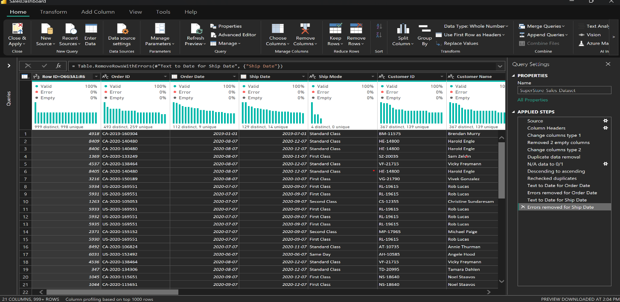

1. Removed two unnecessary columns.
2. Eliminated duplicate records.
3. Replaced missing data with zeros or ones where applicable.
4. Corrected errors in the "Order Date" and "Ship Date" columns by converting them to text format for better handling.
5. After cleaning the data, we saved it for further analysis.

**General Visualizations:**

Created visualizations to compare sales across different regions (East, West, South, Central).

These visualizations help highlight the sales trends in each region and identify areas that need attention.

Central

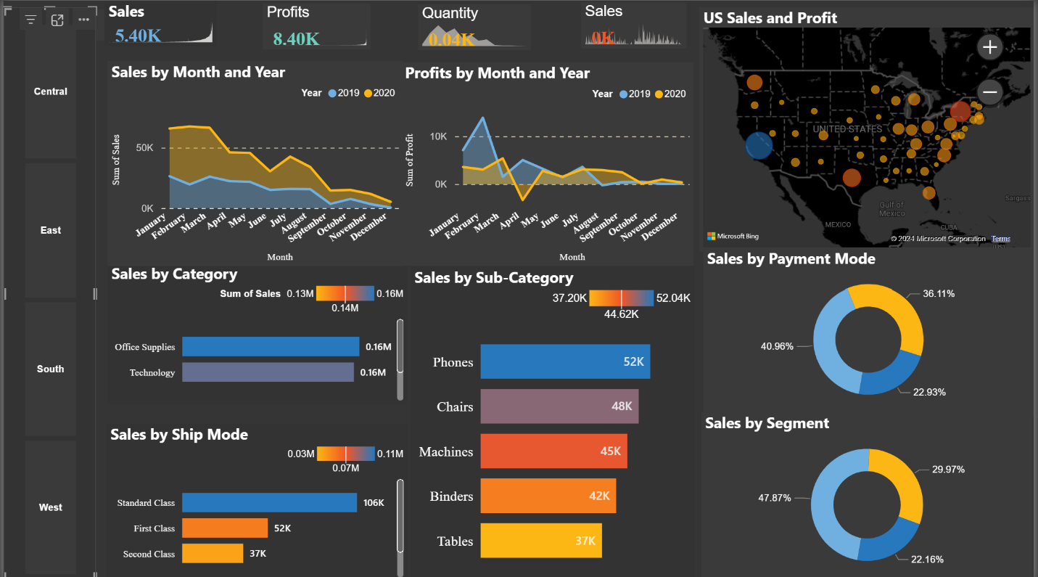

East

South

West

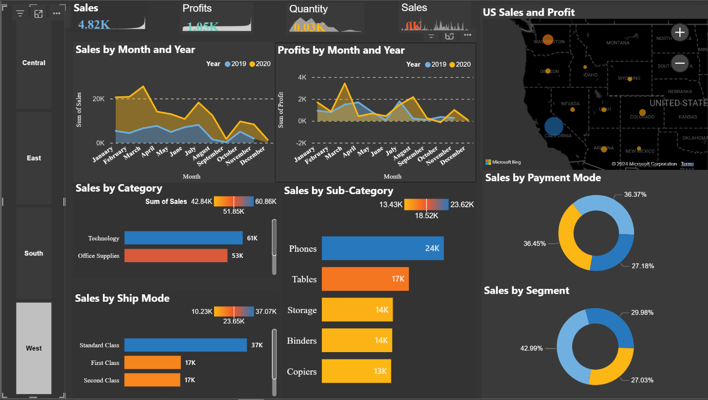

**Sales Forecast Using Linear Regression:**

We applied linear regression to predict future sales trends. This technique helps estimate how sales will behave in the coming days based on historical data.

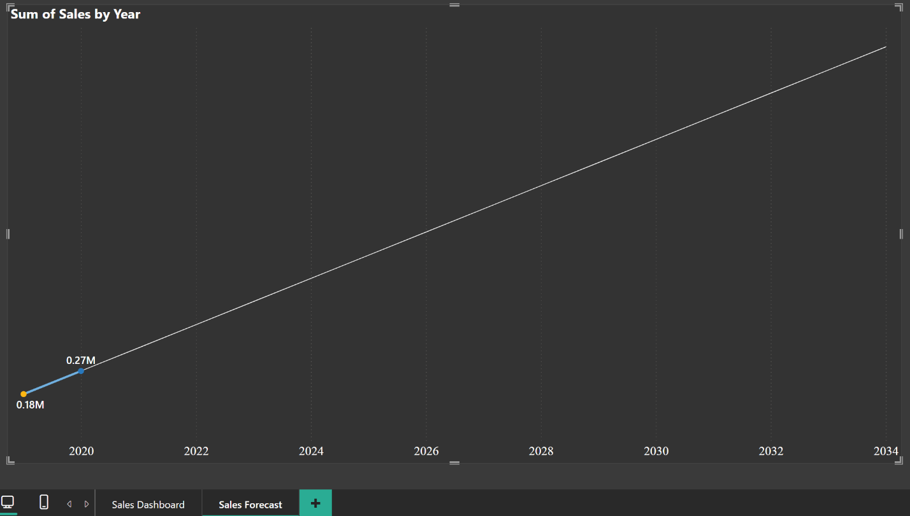

**Analysis:**

By visualizing the data, we could clearly see the sales patterns in each region, such as which regions performed better, and which ones needed improvements.

The forecast helps estimate future sales, assisting the company in planning its resources and marketing strategies accordingly.

**Conclusion:**

This dashboard and forecasting model offer valuable insights into the company’s sales performance and help predict future trends. The insights can guide decisions about marketing, inventory, and regional strategies to improve overall sales performance.